16-bit Addition, Subtraction & Shift Using 8085

Lab Report 2

# Title: 16-bit Arithmetic and Logical Shift Operations Using 8085 Microprocessor

## Objective

To perform 16-bit addition, subtraction, and 4-bit right shift operations using the 8085 microprocessor by accessing data from memory locations and registers, and storing the results appropriately.

## Questions

Add the 16-bit number in memory location 4000H and 4001H to the 16-bit number in memory location 4002H and 4003H. The most significant eight bits of the two numbers to be added are in memory location 4001H and 4003H. Store the result in memory locations 4004H and 4005H with the most significant byte in memory location 4005H

Program:

LDA 4000H  
MOV E,A  
  
LDA 4001H  
MOV D,A  
  
LDA 4002H  
MOV C,A  
  
LDA 4003H  
MOV B,A  
  
MOV A,E  
ADD C  
MOV L,A  
  
MOV A,D  
ADC B  
MOV H,A  
  
MOV A,L  
STA 4004H  
MOV A,H  
STA 4005H  
  
HLT

Output

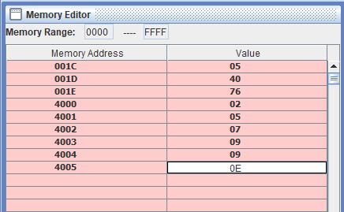

Flowchart:

Start → Load [4000H] → E → Load [4001H] → D  
→ Load [4002H] → C → Load [4003H] → B  
→ A = E + C → Store in L  
→ A = D + B + Carry → Store in H  
→ Store L → [4004H], H → [4005H] → Stop

Subtract the 16-bit number in memory locations 4002H and 4003H from the 16 bit number in memory locations 4000H and 4001H. Store the result in memory locations 4004H and 4005H with the most significant byte in memory location 4005HProgram:

**program**

LDA 4000H  
MOV E,A  
  
LDA 4001H  
MOV D,A  
  
LDA 4002H  
MOV C,A  
  
LDA 4003H  
MOV B,A  
  
MOV A,E  
SUB C  
MOV L,A  
  
MOV A,D  
SBB B  
MOV H,A  
  
MOV A,L  
STA 4004H  
MOV A,H  
STA 4005H  
  
HLT

Flowchart:

Start → Load [4000H] → E → Load [4001H] → D  
→ Load [4002H] → C → Load [4003H] → B  
→ A = E - C → Store in L  
→ A = D - B - Borrow → Store in H  
→ Store L → [4004H], H → [4005H] → Stop

**Output**

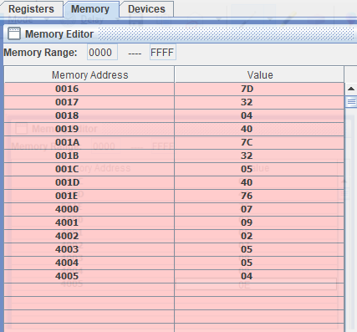

## Write a program to shift eight-bit data four bits right. Assume that the data is in register C

Program:

MVI C,05H  
MOV A,C  
RRC  
RRC  
RRC  
RRC  
HLT

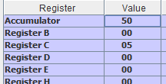

Flowchart:

Start → Load immediate value to C  
→ Copy C to A  
→ Rotate A right 4 times  
→ Stop

## Conclusion

In this lab, we successfully performed 16-bit arithmetic operations (addition and subtraction) using the 8085 microprocessor. We also implemented a logical right shift operation using repeated RRC instructions. These exercises demonstrated the handling of multi-byte data and bitwise operations with accuracy and efficiency using simple instruction sequences.